Web AppBuilder Workshop

*In this exercise, you will walk through the process of creating a License and Inspections (L + I) Web AppBuilder application. This will give you experience with basic widget configuration and previewing your application.*

* Login to your own ArcGIS Online organization or to [localgovne.maps.arcgis.com](http://localgovne.maps.arcgis.com/) using the credential instructions below:
  + Credential instructions:
    1. Visit <http://bit.ly/credential-checkout> and enter your name next to one of the usernames
    2. Use the provided password
    3. Follow initial login instruction as provided
* Navigate to your *Content* page
* Click the *Create* button
  + Click *Using the Web AppBuilder*
  + Enter a Title and Tags. Provide a Summary, then choose the folder in which the application will be saved
  + Click *OK*

*You will be automatically launched into the builder mode for your new application. Here, the first thing you will do is select the map that the app will be configured around. In this example, you will be using the map that shows L + I violations that occurred in the past week.*

* To bring in the web map, select the map icon

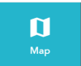

* Click *Choose web map*
  + From the dialog window, click *Public*
  + Activate the *ArcGIS Online* radio button
  + Search for the web map entitled *L + I Violations (Within the Last Week)*
  + Select the map
  + Click *OK*

The map will be added to the builder mode and you can now begin configuring your Web AppBuilder application around it. The next step will be to select a theme. Themes are a great way to tailor your application to your liking.

* Click the *Theme* Icon

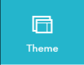

* Take some time to explore the 9 themes. Each theme has a variety of styles and layouts to choose from.
* Click the *Dashboard Theme.* Under *Style* select a color from the list of options.

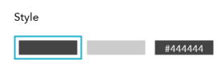

* Under *Layout* select the first layout option, your builder should look like this…

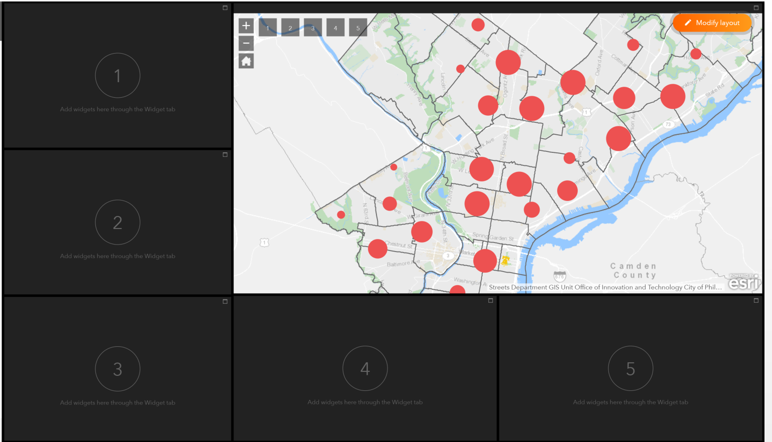

* You can modify the layout of this theme by clicking the orange *Modify layout* button in the top right corner.
* To recreate the *L + I Status Web AppBuilder application* you’ll need to remove a few boxes
  + Click the x in the top right corner of the 2nd and the 4th box
* You can also adjust the sizing the boxes. Hover over the line between the 2 left stacked boxes, An up/down arrow cursor will appear. Click the line and drag it down to meet the top of the rectangular box (like the screen shot below). Click *OK* to save your changes.

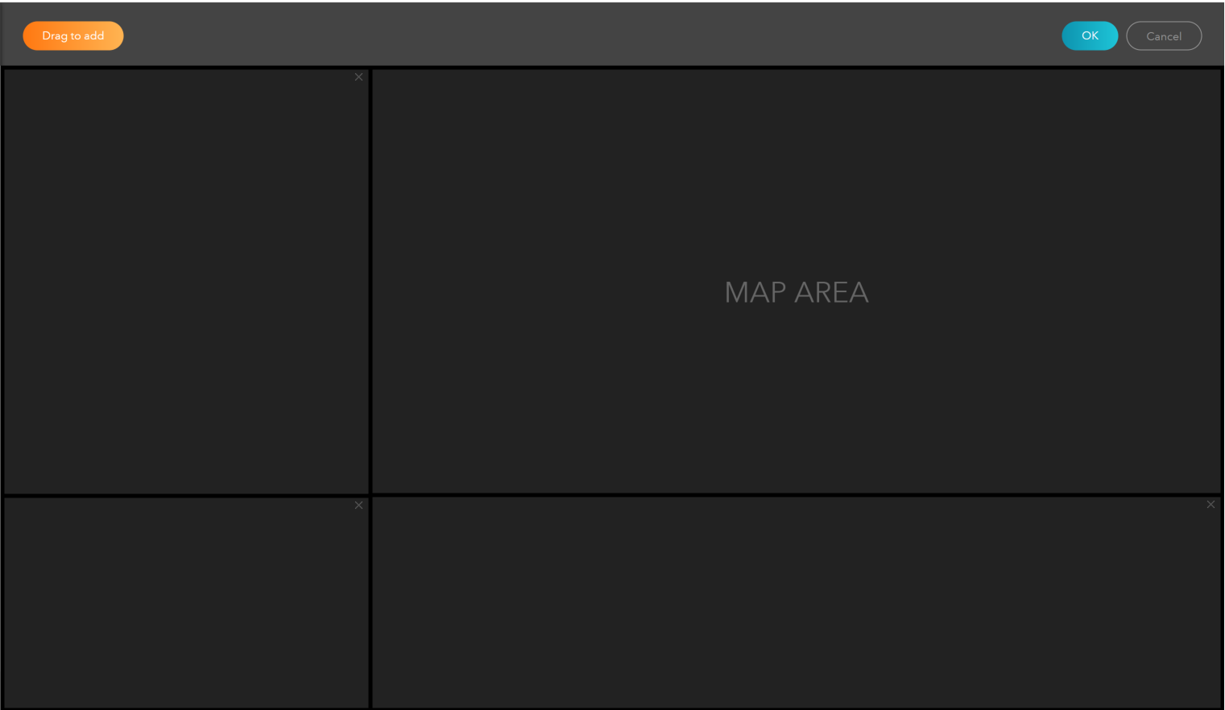

Now that you have configured the layout of the Dashboard Theme you can begin adding Widgets. There are over 30 widgets available in Web AppBuilder to configure around your map data.

In this next part we will be configuring the widgets that appear in the dashboard area. These specific widgets allow you to visualize your map data in dynamic charts, graphs and indicators.

* Click the Widget Icon, this will open the widget panel.

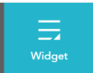

* You’ll see 3 widget icons that appear at the top of the widget panel. These control the widgets that appear in the 3 boxes you just modified.

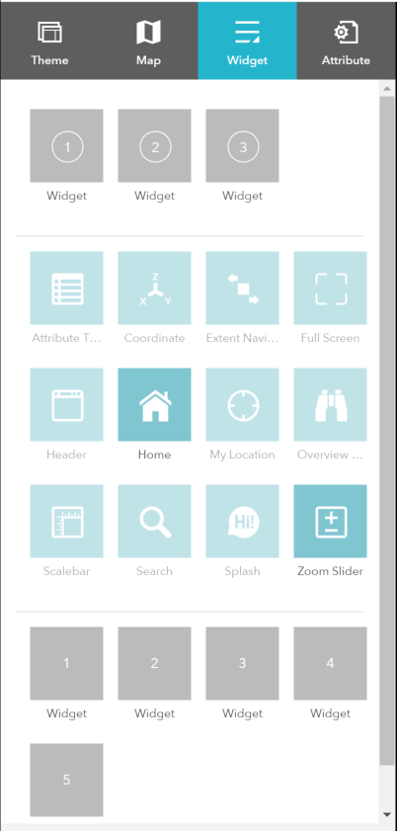

* Click the widget box labeled *1.*
  + Click the *Infographic* widget then click *OK.*
  + Click the *Bar Chart* template then click *OK.*
* The *Set data source* window will appear. Under the *Map* header select the layer titled *L + I Violations (Last 30 days)* and click *OK.*
* Next, you will set up the widget in the *Configure Infographic* window.
* In the chart preview, click where it says *No data.* This activates the *Chart Settings.* Set up the bar chart to display the count of violations by type. Configure the *Data* settings as follows…

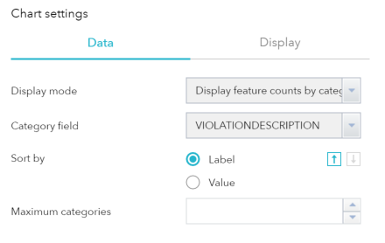

* Once you update the *Data* settings you’ll see the chart preview update.
* You also have control over the styling of the chart. Click *Display* and take some time to explore these settings.
* Give the chart a title and a description
  + In the chart preview, click the text that says *TITLE OF THE INFOGRAPHIC.*
  + The *Text Settings* for the title appear to the right. Add a title for the chart and take some time to adjust the styling.
  + In the chart preview, click the text that says *Description: additional information about this infographic.* and update the text settings.
* Optionally, you can remove any part of the widget by clicking one of the following icons…



* Lastly, click the box next to *Filter by extent.* Now, when you pan and zoom around the map the widget will update to show the count of violations within that area. You have successfully configured your first widget. Click *OK.*
* Next, you’ll use the *Infographic* widget again. But, this time you’ll configure it using the *Pie Chart* template.
  + Click the widget box labeled *1* and navigate to the configuration window for the pie chart. (*HINT: if you need assistance getting to the configuration window, see instructions for the previous widget.*)

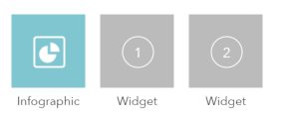

* Configure the *Chart Settings* to show feature counts by violation status. Also, take some time to set up the title, description and display of the widget. Click *OK* when you are finished.

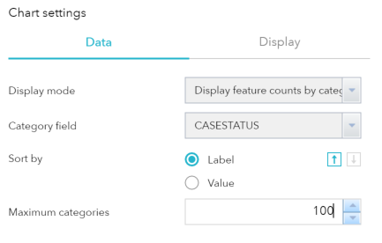

* At this point you have one more widget to add to your layout. Set this widget up using the *Line Chart* template to display the feature count of violations by date. Click *OK* when you are finished.

In this last part, you’ll use the additional widget options to configure a *Filter* widgetand a *Legend* widget. The widgets will appear in the top left of the map area and can be configured in the *Widget* panel.

* Make sure you still have the *Widget* panel open. At the bottom of the panel you’ll see 5 numbered boxes. You can configure each of these as widgets in your app.
* Now you will configure the *Filter* widget.
  + Hover over the box labeled *1.* You’ll see the corresponding widget box highlight in red in the map area. Click on the box.

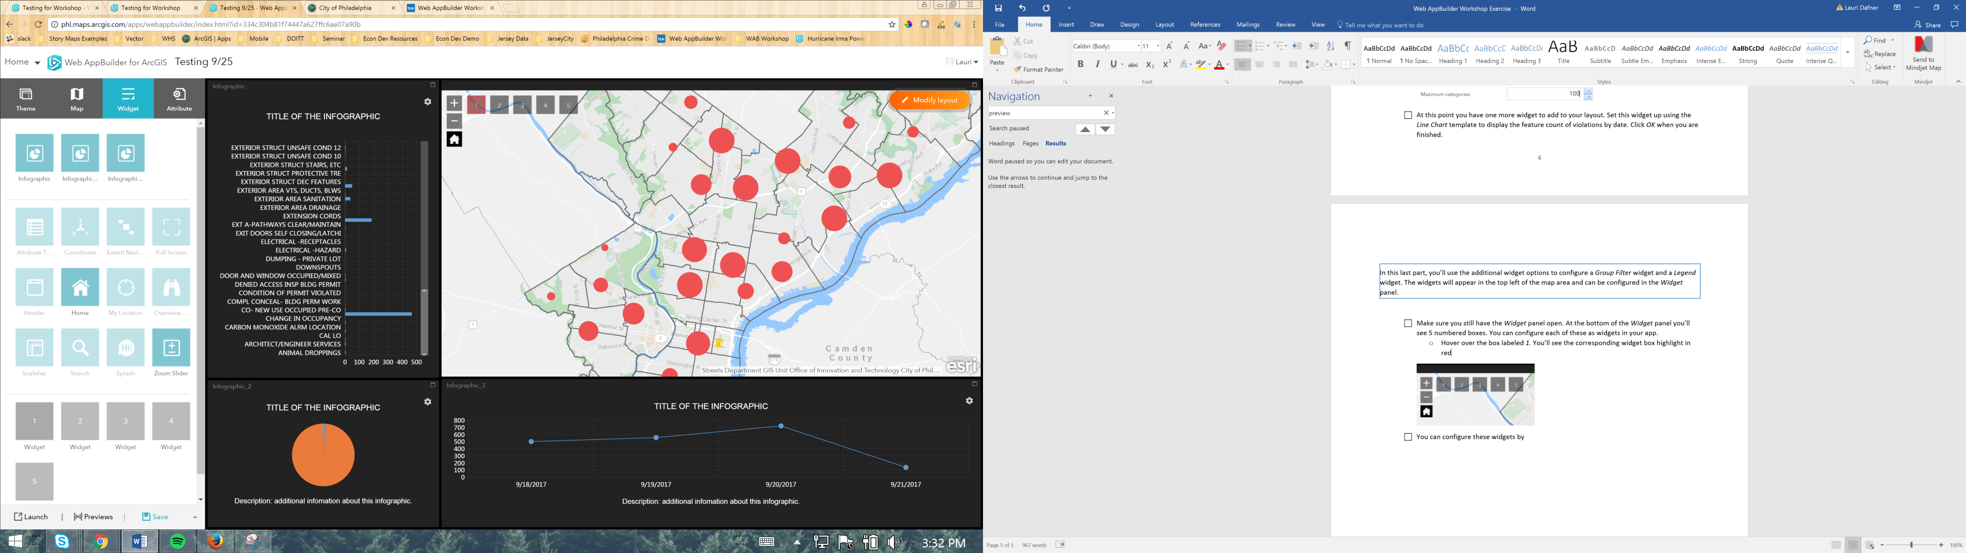

* + The *Choose Widget* dialog will open. Click the *Filter* widget. Then click *OK.*
  + Click the *New filter* button and select the *L + I Violations* layer from the *Layer* drop down and add a title for the filter.
  + Under *Filter expression* click *Add an expression* and fill in the following…

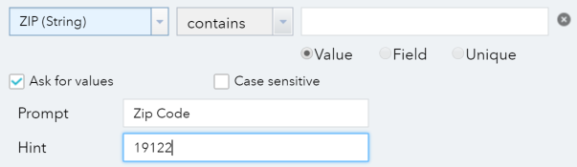

* Use the same workflow to add a *Legend* widget next to the *Filter* widget.
* Click *Save* to preserve the changes you made. Remember, this application is saved in your My Content section of ArcGIS Online, under the folder you specified when you initially opened Web AppBuilder. You can find the item there to access it later, change the sharing settings, etc.
* Click *Previews* to explore how your application would look using different devices. Note that the preview is dynamic – you can interact with the map and widgets as if you were using it on the chosen device.
* Click *Launch* to open the application in a web browser, outside of builder mode. This is how your application will appear to end users. The URL that appears in the browser is the final link to your application that you can share as needed.